**Mathematics-for-Machine-Learning**

1. Getting handle on vectors:
   1. Definition:
      1. Vectors are usually viewed by computers as an ordered list of numbers which they can perform "operations" on - some operations are very natural and, as we will see, very useful!
      2. A vector in space-time can be described using 3 dimensions of space and 1 dimension of time according to some co-ordinate system.
      3. Vectors can be thought of in a variety of different ways - some geometrically, some algebraically, some numerically. In this way, there are a lot of techniques one can use to deal with vectors.
   2. Vector is just something that are based on two rules. Firstly, addition, and secondly, multiplication by a scalar number.
      1. Addition:
 $r= \left[\begin{matrix}3 \\ 2\end{matrix}\right], s=\left[\begin{matrix}-1 \\ 2\end{matrix}\right]$

 $r+s=s+r(associativity)=\left[\begin{matrix}3-1 \\ 2+2\end{matrix}\right]=\left[\begin{matrix}2 \\ 4\end{matrix}\right]$

    2. Multiplication:
$r= \left[\begin{matrix}3 \\ 2\end{matrix}\right],$

$2r= \left[\begin{matrix}3⋅2 \\ 2⋅2\end{matrix}\right]=\left[\begin{matrix}6 \\ 4\end{matrix}\right]$

2. Finding the size of vectors, its size and projection
 $r=\left[\begin{matrix}3 \\ 2\end{matrix}\right], s=\left[\begin{matrix}-1 \\ 2\end{matrix}\right]$

  1. Size of vectors = $\left|r\right|=\sqrt{3^{2}+2^{2}}$ = $\sqrt{9+4 }$
   2. Dot product of vectors:
 $r⋅s=s⋅r=r_{11}⋅s_{11}+r_{21}⋅s_{21}=3⋅\left(-1\right)+2⋅2=1$

  3. Cosine rule = $r⋅s=\left|r\right|⋅\left|s\right|⋅\cos{θ}$
   4. Projection = dot product gives us, is it gives us the projection here of S on to R times the size of R. And one thing to notice here is that if S was perpendicular to R, if S was pointing this way, it would have no shadow. 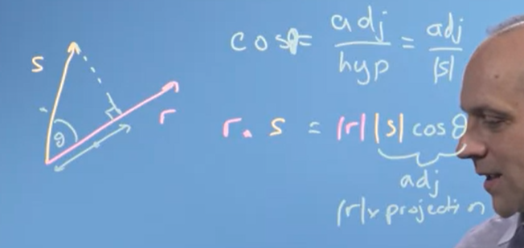
      1. Vector projection = $\frac{r⋅s}{r⋅r}⋅r$
      2. Scalar projection = $\frac{r⋅s}{r}$
3. Changing basis:
   1. Any vector space has multiple bases, so the question naturally arises: what are the relationships between bases of a vector space? In the first place, there must be the same number of elements in any basis of a vector space. Then, given two bases of a vector space, there is a way to translate vectors in terms of one basis into terms of the other; this is known as change of basis.

Change of basis is a technique applied to finite-dimensional vector spaces in order to rewrite vectors in terms of a different set of basis elements. It is useful for many types of matrix computations in linear algebra and can be viewed as a type of linear transformation.

* 1. 1)
  2. 2)

1. Basis, vector space and linear independence
   1. Basis is a set pf n vectors that:
      1. Are not linear combination of each other(Linear independent)
      2. Span the space
      3. The space is n-dimensional
   2. Linear independence:

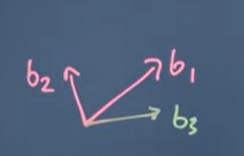

* + 1. if detM≠0, the given vectors are linearly independent

1. Gaussian elimination
   1. Gaussian elimination, also known as row reduction, is an algorithm in linear algebra for solving a system of linear equations. It is usually understood as a sequence of operations performed on the corresponding matrix of coefficients.

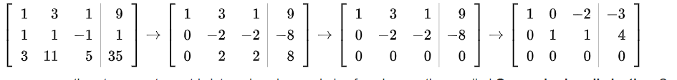

1. Transformation in a changed basis and changing basis: 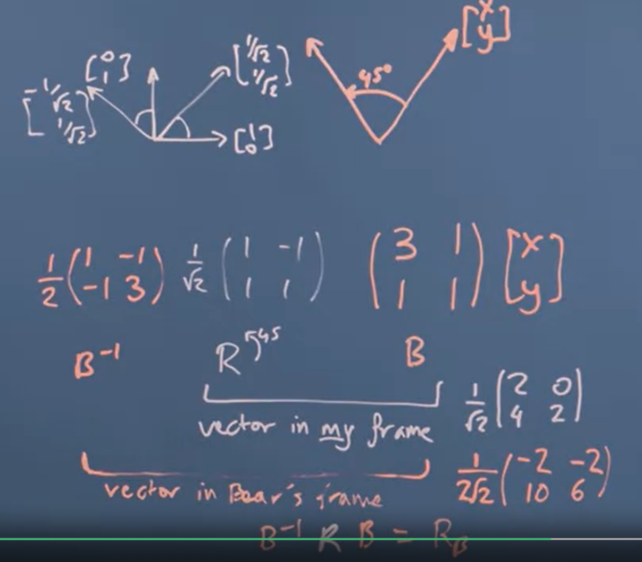
2. Orthogonal matrices
   1. $A_{ij}^{T}=A_{ji}$, $A=\left[\begin{matrix}1 & 2 \\ 3 & 4\end{matrix}\right], A^{T}=\left[\begin{matrix}1 & 3 \\ 2 & 4\end{matrix}\right]$
   2. Orthogonal matrixes –
 $Q^{T}⋅Q=I$

 $Q^{T}=Q^{-1}$

 3. A set of unit length basis vectors that are all perpendicular to each other are called an orthonormal basis set, and the matrix composed of them is called an orthogonal matrix. $a_{i}⋅a_{j}=0 if i≠j, a_{i}⋅a_{j}=1 if i=j$
3. The Gram–Schmidt process

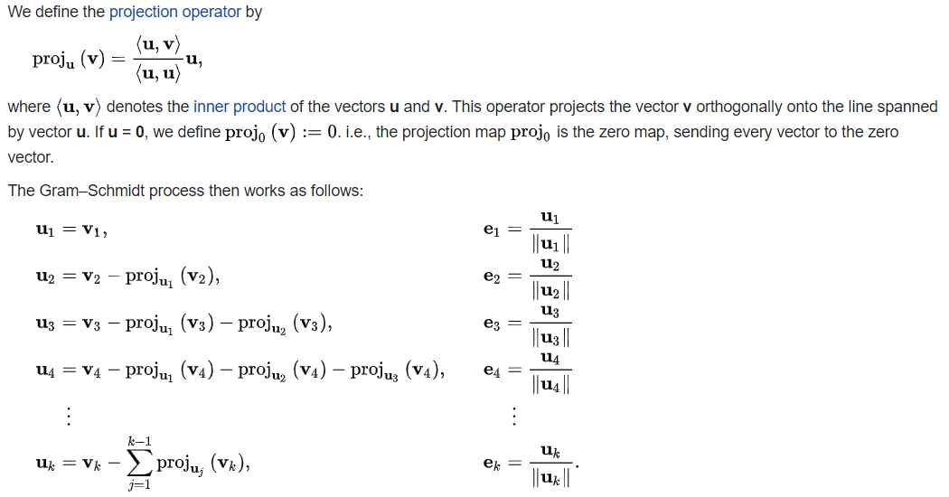

* 1. Gram–Schmidt process is a method for orthonormalizing a set of vectors in an inner product space, most commonly the Euclidean space

1. Transformation matrix for reflecting vectors in an arbitrarily angled mirror, construct an orthonormal basis that spans a set of input vectors $T=ET_{E}E^{-1}$, $r^{-1}=T⋅r$
2. Eigenvalues and Eigenvectors:
   1. In linear algebra, an **eigenvector** or **characteristic vector** of a linear transformation is a nonzero vector that changes by a scalar factor when that linear transformation is applied to it. The corresponding eigenvalue, often denoted by $λ$ is the factor by which the eigenvector is scaled.
   2. How to find eigenvectors and eigenvalues
 $A= \left[\begin{matrix}0 & -1 \\ 1 & 0\end{matrix}\right]$

 $Ax=λx;\left(A-λI\right)x=0$

 $det\left(\left[\begin{matrix}-λ & -1 \\ 1 & -λ\end{matrix}\right]\right)= λ^{2}+1;λ=1 and λ=-1$

$@λ=1$

$\left[\begin{matrix}-1 & -1 \\ 1 & -1\end{matrix}\right]\left[\begin{matrix}x_{1} \\ x_{2}\end{matrix}\right]=\left[\begin{matrix}0 \\ 0\end{matrix}\right]$

$\left\{\begin{aligned}-x_{1}-x_{2}=0 \\ x_{1}-x_{2}=0\end{aligned}\right.$

$\left\{\begin{aligned}x_{2}=0 \\ x_{1}=0\end{aligned}\right.$

$@λ=-1$

$\left[\begin{matrix}1 & -1 \\ 1 & 1\end{matrix}\right]\left[\begin{matrix}x_{1} \\ x_{2}\end{matrix}\right]=\left[\begin{matrix}0 \\ 0\end{matrix}\right]$

$\left\{\begin{aligned}x_{1}-x_{2}=0 \\ x_{1}+x_{2}=0\end{aligned}\right.$

$\left\{\begin{aligned}x_{1}=x_{2} \\ x_{2}=0\end{aligned}\right.$

3. To find $T^{n}$ we use diagonalization for ex:
 $T=\left[\begin{matrix}1 & 0 \\ 2 & -1\end{matrix}\right]$

     1. The find eigenvectors:

$\left(1-λ\right)\left(-1-λ\right)=0$

$λ=1 and λ=-1$

$@λ=1$

$\left\{x_{1}=x_{2}\right.$

$v_{1}=\left[\begin{matrix}1 \\ 1\end{matrix}\right]$

$@λ=-1$

$\left\{x_{1}=0\right.$

$v_{2}=\left[\begin{matrix}0 \\ 1\end{matrix}\right]$

$T^{n}=C⋅D⋅C^{-1}$

$C=\left[v_{1}, v_{2}\right]=\left[\begin{matrix}1 & 0 \\ 1 & 1\end{matrix}\right]$

$C^{-1}=\left[\begin{matrix}1 & 0 \\ -1 & 1\end{matrix}\right]$

$D=\left[\begin{matrix}λ_{1} & \\ & λ_{2}\end{matrix}\right]=\left[\begin{matrix}1 & 0 \\ 0 & -1\end{matrix}\right]$

$T^{n}=C⋅D^{n}⋅C$